# Lab: Syntax, Functions and Statements

Problems for in-class lab for the ["JavaScript Advanced" course @ SoftUni](https://softuni.bg/courses/js-advanced). Submit your solutions in the SoftUni judge system at <https://judge.softuni.bg/Contests/2749/Syntax-Functions-and-Statements-Lab>

## Echo Function

Write a JS function that takes **one string parameter** and **prints** on two lines the **length** of the parameter and then the **unchanged parameter** itself.

### Examples

|  |  |
| --- | --- |
| **Input** | **Output** |
| 'Hello, JavaScript!' | 18  Hello, JavaScript! |
| 'strings are easy' | 16  strings are easy |

### Hints

* Write a function that receives a single **parameter**.
* Use the console.log function to print text on the console. Each call prints a new line automatically.
* The string’s length **property** is used to determine how many characters are in a given string

## String Length

Write a JS function that takes **three** **string arguments** as an input.

Calculate the **sum** of the **length** of the **strings** and the **average length** of the strings **rounded** **down** to the nearest integer.

The **input** comes as **three string arguments** passed to your function.

The **output** should be printed on the console on two lines.

### Examples

|  |  |
| --- | --- |
| **Input** | **Output** |
| 'chocolate', 'ice cream', 'cake' | 22  7 |
| 'pasta', '5', '22.3' | 10  3 |

### Hints

* Write a function that receives three string arguments.
* Declare two variables named sumLength and averageLength that will keep the mathematical results.
* Calculate the length of the strings using the length **property**.

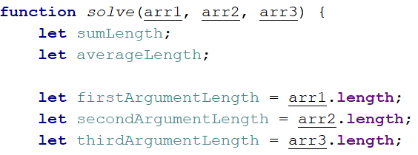

* Calculate the sum of the three lengths. 
* Calculate the **average length** of the strings **rounded** **down** to the nearest integer. Use the Math.floor() function.



* Print the results on the console.

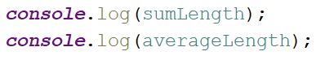

## Largest Number

Write a function that takes **three number arguments** as an input and find the **largest** of them. Print the following text on the console: '**The largest number is {number}.**'.

The **input** comes as **three number arguments** passed to your function.

The **output** should be printed to the console.

### Example

|  |  |
| --- | --- |
| **Input** | **Output** |
| 5, -3, 16 | The largest number is 16. |
| -3, -5, -22.5 | The largest number is -3. |

### Hints

* Write a function that receives three number arguments.
* Declare a variable named result that will keep the result.

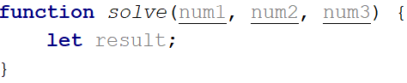

* Make several checks to find out the largest of the three numbers. Start with num1.

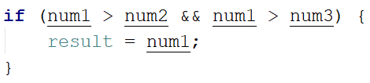

* Do the same for the others.

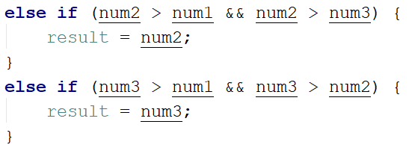

* Print the result on the console.



## Circle Area

Write a function that takes **a single argument** as an input.

**Check the type** of the input argument. If it is a **number**, assume it is the radius of a circle and **calculate the circle area**. Print the **area** **rounded** to **two decimal places**.

If the argument type is **NOT** a number, print the following text on the console:   
'We can not calculate the circle area, because we receive a {type of argument}.'

The **input** comes as a **single argument** passed to your function.

The **output** should be printed on the console.

### Example

|  |  |
| --- | --- |
| **Input** | **Output** |
| 5 | 78.54 |
| 'name' | We can not calculate the circle area, because we receive a string. |

### Hints

* Write a function that receives a single argument.
* Declare a variable named result that will keep your result.

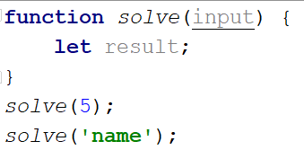

* Check the type of the input argument with the typeof operator.



* If the type is equal to 'number', calculate the circle area and print it on the console rounded to two decimal places. To do this, use the method toFixed().  
  The Math.pow() function returns the base to the exponent power, that is, base exponent. You can find more information about the area [here](https://en.wikipedia.org/wiki/Circle):

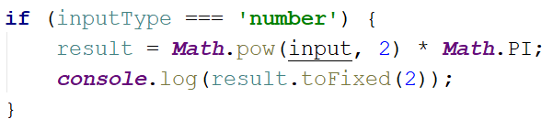

* If the type is **NOT** a 'number', print the following text on the console:

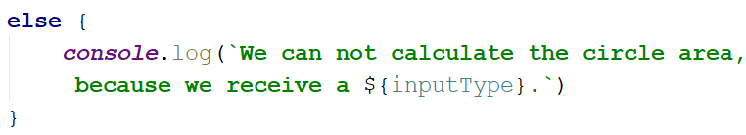

## Math Operations

Write a JS function that takes **two** **numbers** and **a string** as an input.

The string may be one of the following: '**+**', '**-**', '**\***', '**/**', '**%**', '**\*\***'.

Print on the console the result of the mathematical **operation** between **both numbers** and the **operator** you receive as a string.

The **input** comes as **two numbers** and **a string argument** passed to your function.

The **output** should be printed on the console.

### Examples

|  |  |
| --- | --- |
| **Input** | **Output** |
| 5, 6, '+' | 11 |
| 3, 5.5, '*' | 16.5 |

### Hints

* Write a function which receives **three** arguments:

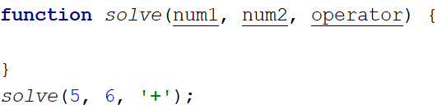

* Declare a variable named result that will keep your mathematical result.
* Write down switch command that will take the string from your input and depending on it, perform the mathematical logic between the two numbers.

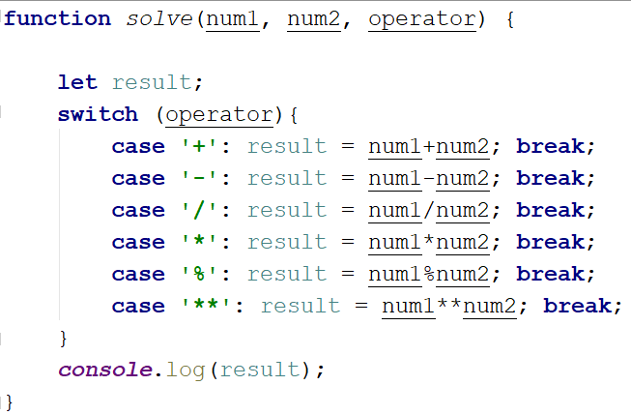

* Print the result on the console.



## Sum of Numbers N…M

Write a JS function that takes two numbers **n and m** as an input and **prints the sum** of all numbers from **n** to **m**.

The **input** comes as **two string elements** that need to be **parsed** as numbers.

The **output** should return the **sum**.

### Examples

|  |  |
| --- | --- |
| **Input** | **Output** |
| '1', '5' | 15 |
| '-8', 20' | 174 |

### Hints

* Write a function that receives two string arguments and parse them as numbers. Use Number(string) function to parse the input.

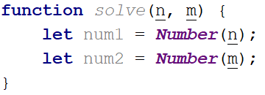

* Declare a variable named result that will keep the mathematical results.
* Write a for loop from num1 to num2 and for every turn of the cycle, until it’s completed, add the current value.

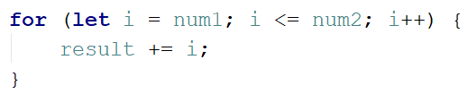

* Finally, return the result.



## Day of Week

Write a function that prints a number between 1 and 7 when a **day of the week** is passed to it as a string and an **error message** if the string is **not recognized**.

The **input** comes as a single string argument.

The **output** should be returned as a result.

### Examples

|  |  |
| --- | --- |
| **Input** | **Output** |
| Monday | 1 |
| Friday | 5 |
| Invalid | error |

## Square of Stars

Write a function that **prints a rectangle** made of **stars** with variablesize, depending on an input parameter. If there is **no parameter** specified, the rectangle should **always** be of **size 5**. Look at the examples to get an idea.

The **input** comes as a single **number** argument.

The **output** is a series of lines printed on the console, forming a rectangle of variable size.

### Examples

|  |  |  |  |  |  |  |  |  |  |  |
| --- | --- | --- | --- | --- | --- | --- | --- | --- | --- | --- |
| **Input** | **Output** |  | **Input** | **Output** |  | **Input** | **Output** |  | **Input** | **Output** |
| 1 | * | 2 | * *  * * | 5 | * * * * *  * * * * *  * * * * *  * * * * *  * * * * * |  | * * * * *  * * * * *  * * * * *  * * * * *  * * * * * |

## Aggregate Elements

Write a program that performs different operations on an array of elements. Implement the following operations:

* **Sum(ai)** - calculates the sum all elements from the input array
* **Sum(1/ai)** - calculates the sum of the inverse values (1/ai) of all elements from the array
* **Concat(ai)** - concatenates the string representations of all elements from the array

The **input** comes as an array of number elements.

The **output** should be printed on the console on a new line for each of the operations.

### Examples

|  |  |  |  |  |
| --- | --- | --- | --- | --- |
| **Input** | **Output** |  | **Input** | **Output** |
| [1, 2, 3] | 6  1.8333  123 | [2, 4, 8, 16] | 30  0.9375  24816 |